Set Up Guide

1. Install Necessary Programs
• NetBeans
•JDK
• GlassFish(Part of Netbeans)
• MySQL Server
• MySQL Workbench
• MySQL Java Connector (Driver)
• OpenSSL

2. Configure OpenSSL

Creating SSL Files on Windows
Download OpenSSL for Windows if it is not installed on your system. An overview of available packages can be seen here:
http://www.slproweb.com/products/Win32OpenSSL.html
Choose the Win32 OpenSSL Light or Win64 OpenSSL Light package, depending on your architecture (32-bit or 64-bit). The default installation location will be C:\OpenSSL-Win32 or C:\OpenSSL-Win64, depending on which package you downloaded. The following instructions assume a default location of C:\OpenSSL-Win32. Modify this as necessary if you are using the 64-bit package.
If a message occurs during setup indicating '...critical component is missing: Microsoft Visual C++ 2008 Redistributables', cancel the setup and download one of the following packages as well, again depending on your architecture (32-bit or 64-bit):
• Visual C++ 2008 Redistributables (x86), available at:
• http://www.microsoft.com/downloads/details.aspx?familyid=9B2DA534-3E03-4391-8A4D-074B9F2BC1BF
• Visual C++ 2008 Redistributables (x64), available at:
• http://www.microsoft.com/downloads/details.aspx?familyid=bd2a6171-e2d6-4230-b809-9a8d7548c1b6
After installing the additional package, restart the OpenSSL setup procedure.
During installation, leave the default C:\OpenSSL-Win32 as the install path, and also leave the default option 'Copy OpenSSL DLL files to the Windows system directory' selected.
When the installation has finished, add C:\OpenSSL-Win32\bin to the Windows System Path variable of your server:
- Press the Windows key and R on the keyboard. The Windows key is located on the highlighted portions of the keyboard.

- In the Run dialog box, type “Control Panel” and click OK.
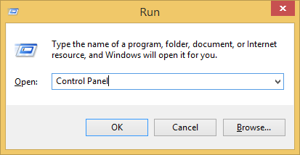

- Click “System” in the Control Panel.
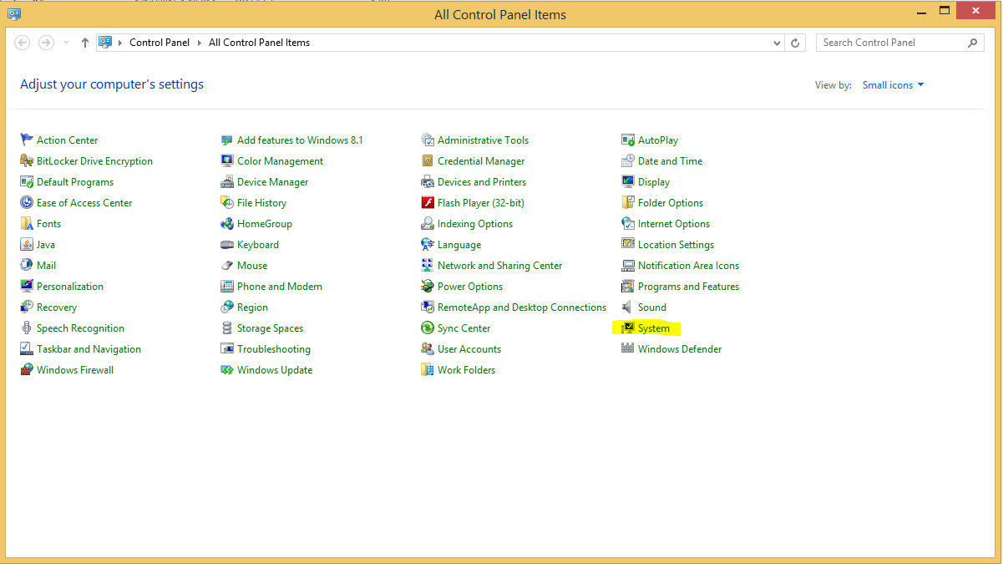
- Click “Advanced system settings”.
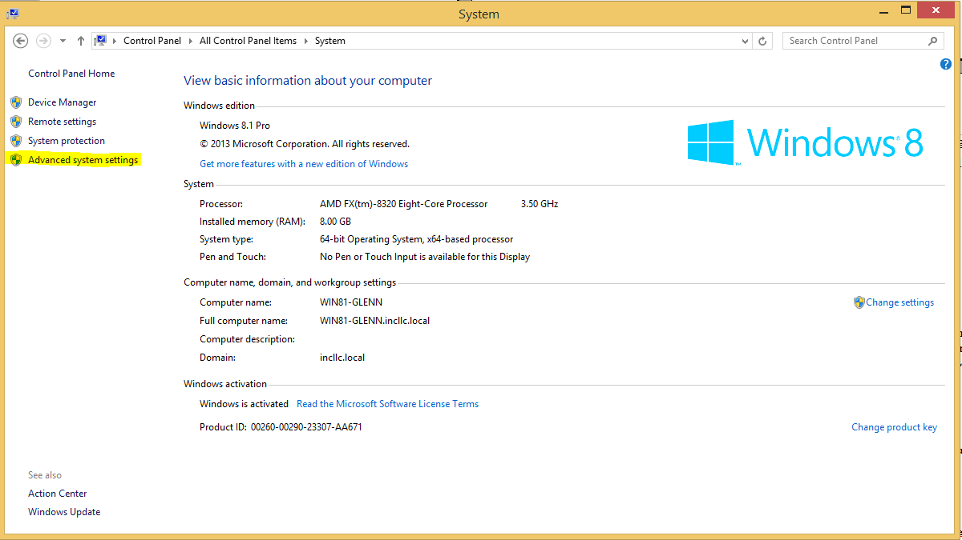

- Select the Advanced tab from the System Properties menu that appears, and click the Environment Variables button.
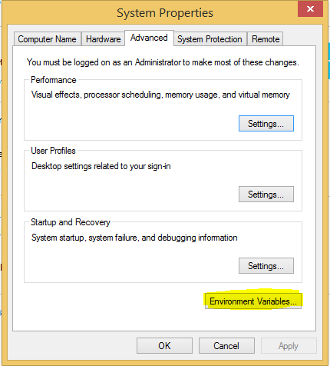

- Under System Variables, select “Path”, then click the Edit button. The Edit System Variable dialogue should appear.
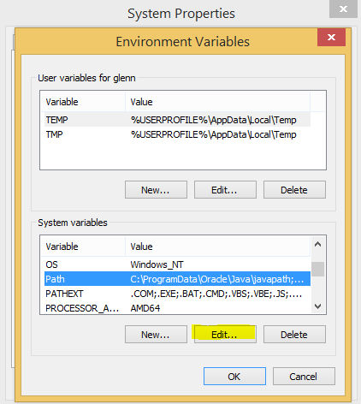

- Add ';C:\OpenSSL-Win32\bin' to the end. Then click OK.
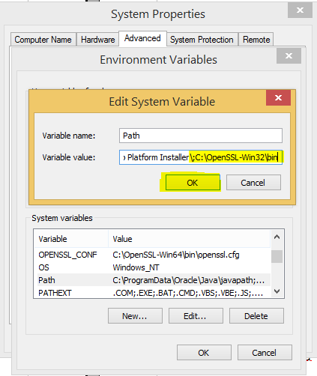

- Click OK again.
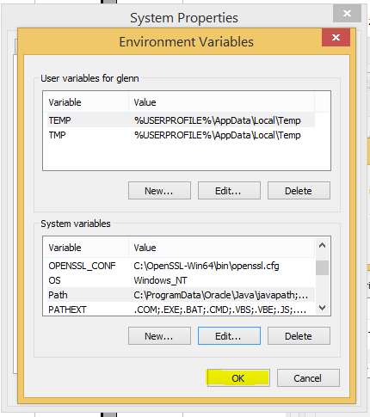
- Click OK one last time.
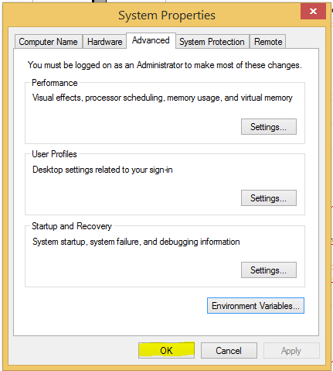
- Check that OpenSSL was correctly integrated into the Path variable by opening a new command console and verifying that OpenSSL is available.
To open a new command console press Windows key and R again and type “cmd”.
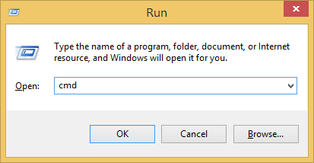
- Within the command console, type “cd \” like below.
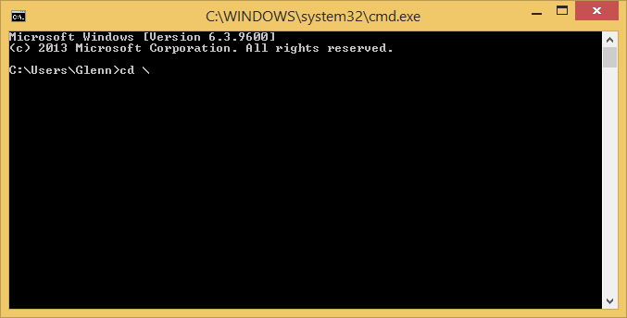
- Then press Enter and it should look like this.
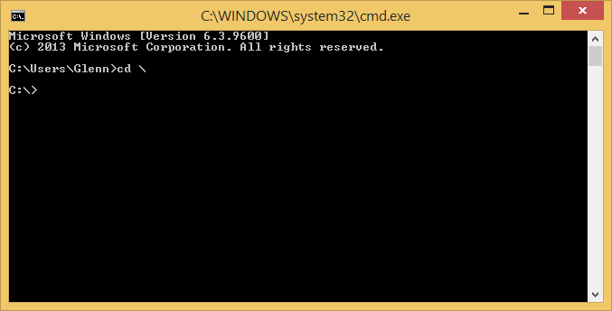
- Now within the command console type “openssl”.
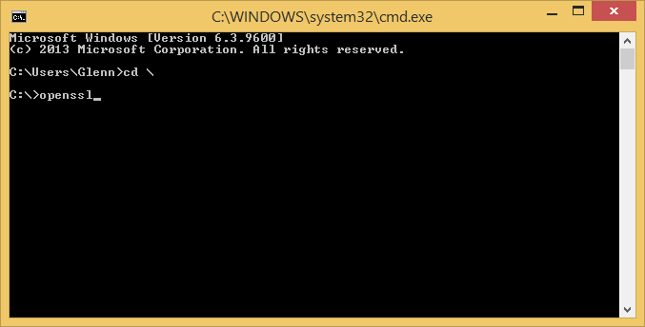
- Then press Enter and it should look like this.
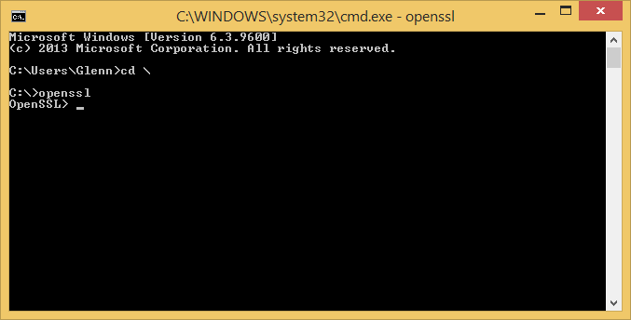
- If you see the above screen the installation of OpenSSL was successful.
After OpenSSL has been installed, use instructions similar to those from Example 1 (shown earlier in this section), with the following changes:
On Windows, use these commands:
# Create clean environment
md c:\newcerts
cd c:\newcerts

Creating SSL Files from the Command Line
The following example shows a set of commands to create MySQL server and client certificate and key files. You will need to respond to several prompts by the openssl commands. To generate test files, you can press Enter to all prompts. To generate files for production use, you should provide nonempty responses.
# Create CA certificate
openssl genrsa 2048 > ca-key.pem
openssl req -new -x509 -nodes -days 3600 -key ca-key.pem -out ca.pem
# Create server certificate, remove passphrase, and sign it
# server-cert.pem = public key, server-key.pem = private key
openssl req -newkey rsa:2048 -days 3600 -nodes -keyout server-key.pem -out server-req.pem
openssl rsa -in server-key.pem -out server-key.pem
openssl x509 -req -in server-req.pem -days 3600 -CA ca.pem -CAkey ca-key.pem -set_serial 01 -out server-cert.pem
# Create client certificate, remove passphrase, and sign it
# client-cert.pem = public key, client-key.pem = private key
openssl req -newkey rsa:2048 -days 3600 -nodes -keyout client-key.pem -out client-req.pem
openssl rsa -in client-key.pem -out client-key.pem
openssl x509 -req -in client-req.pem -days 3600 -CA ca.pem -CAkey ca-key.pem -set_serial 01 -out client-cert.pem
After generating the certificates, verify them:
openssl verify -CAfile ca.pem server-cert.pem client-cert.pem
server-cert.pem: OK
client-cert.pem: OK
To see the contents of a certificate (for example, to check the range of dates over which a certificate is valid), invoke openssl like this:
openssl x509 -text -in ca.pem
openssl x509 -text -in server-cert.pem
openssl x509 -text -in client-cert.pem
Now you have a set of files that can be used as follows:
• ca.pem: Use this as the argument to --ssl-ca on the server and client sides. (The CA certificate, if used, must be the same on both sides.)
• server-cert.pem, server-key.pem: Use these as the arguments to --ssl-cert and --ssl-key on the server side.
• client-cert.pem, client-key.pem: Use these as the arguments to --ssl-cert and --ssl-key on the client side.

3 MySQL
1. Navigate to MySQL Workbench→ Add Connection
2. Name connection and leave the rest as defaults. Connect to the server using the newly created connection.
3. Navigate to Option File→ Click on the Networking Tab
4. Check the ssl, ssl-ca, ssl-cert, and ssl-key boxes and set the path addresses to the created ssl certificates completed above(ca.pem, server-cert.pem, server-key.pem).

5. Click Apply and Apply again when the dialog box opens to save changes
6. Click Startup / Shutdown (Left Side Bar) →Click Stop Server
7. Windows Key + R→ Type in services.msc→ Enter→ Find server (Default: MySQL)→ Right click and then Start
8. Return to Workbench and right click connection and edit connection
9. Click the ssl Tab and set the Use SSL box to “Required”.
10. Click Close then retry the connection
11 Make sure to set table names to be case sensitive: lower_case_table_names = 2
NOTE: If you receive any errors trying to complete the steps above, completely uninstall MySQL and do a clean install. Make sure to delete ALL MySQL FILES found in the following directories:
• Program Files
• Program Files (x86)
• Program Data
• %appdata%
• In regedit, delete related files under local computer and current user including wow64

4 NetBeans
JDK must be installed first. Install the full version of Netbeans that includes Glassfish and Java EE from their website.
1. Create folder: C:\NetBeans
2. Check out the repository in the newly created folder
3. Open NetBeans and Click File→ Open Project→ Select All Folders found in the solution
4. Once all project files are loaded in, Click the Projects Tab
- Navigate to incAccounting→ Configuration Files→ web.xml
  - dbServer
  - dbUser
  - dbPassword

7. Build and Run

5 Creating New Database
After running the program, the user is brought to the Login Screen.
1. Click the Menu Button→ Database Setup

2. Type in the root password to the Database(One created on Install of MySQL Server)
3. Test Connection
4. If sent to an error screen, check server to make sure it is running and that SSL certificates have been created and used in the server settings.
5. Click Create Database
6. Set Administrator Password→Click Create Administrator

To make sure database was created, return to MySQL WorkBench and connect to the server. In the sidebar, the new database should appear under “Schemas”

